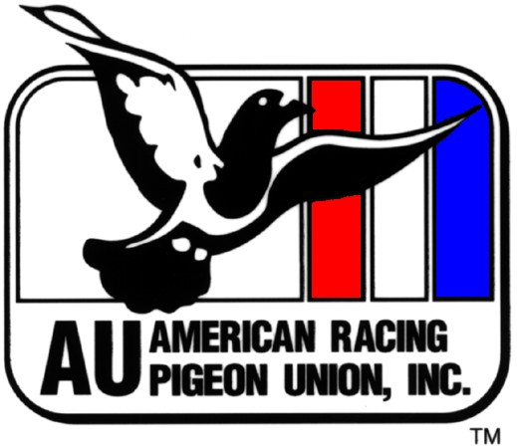
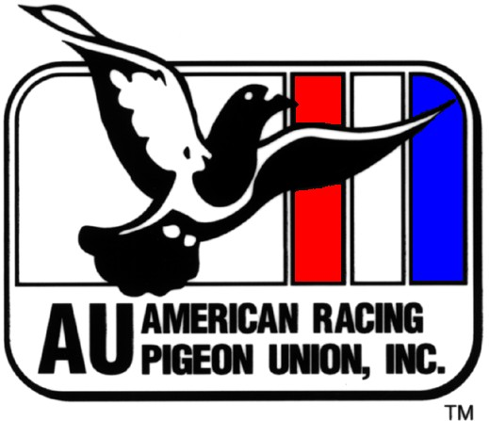
FEDERATION CHARTER APPLICATION
American Racing Pigeon Union, Inc
P.O. Box 18465 Oklahoma City, OK 73154-0465
Phone: 405-848-5801

Federation Name________________________________

LIST FEDERATION OFFICERS BELOW. Official to receive correspondence___________________

Address_______________________________ City __________________ST_______ ZIP___________

- Charter application fee is $25.00 for up to two concourses and $25 for every five additional concourses. (Each combine within the concourses must also be individually chartered with the AU. Each club within the combines must be individually chartered with the AU.)
- Members of clubs within the combines and concourse must be AU members. Annual AU dues are $30 for individual members, $10 for members up to age 17; $40 for family membership.
- List each concourse name to appear on charter.

List all AU chartered concourses that are part of your federation below. On a separate page list the following: all AU clubs in each combine (all clubs in the combine must be AU clubs), and all AU members in each AU club including AU member ID’s (all members of the clubs must be AU members and remain current). Provide a copy of each organization’s local By-laws and Constitution (club, combine, concourse). This shall include any amendments reflecting their agreement to uphold all requirements to maintain their AU charters.

Total # of Concourses___ X appropriate Charter fee $ = Total amount enclosed $
PLEASE PRINT CLEARLY – YOUR CHARTER WILL BE PRINTED FROM INFO PROVIDED BELOW.

 | CONCOURSE NAME | ADDRESS | CITY, ST, ZIP | PHONE
1
2
3
4
5
6
7
8
9
10
11
12
13

, Federation President , Federation VP
, Federation Secretary , Fed. Race Sec

